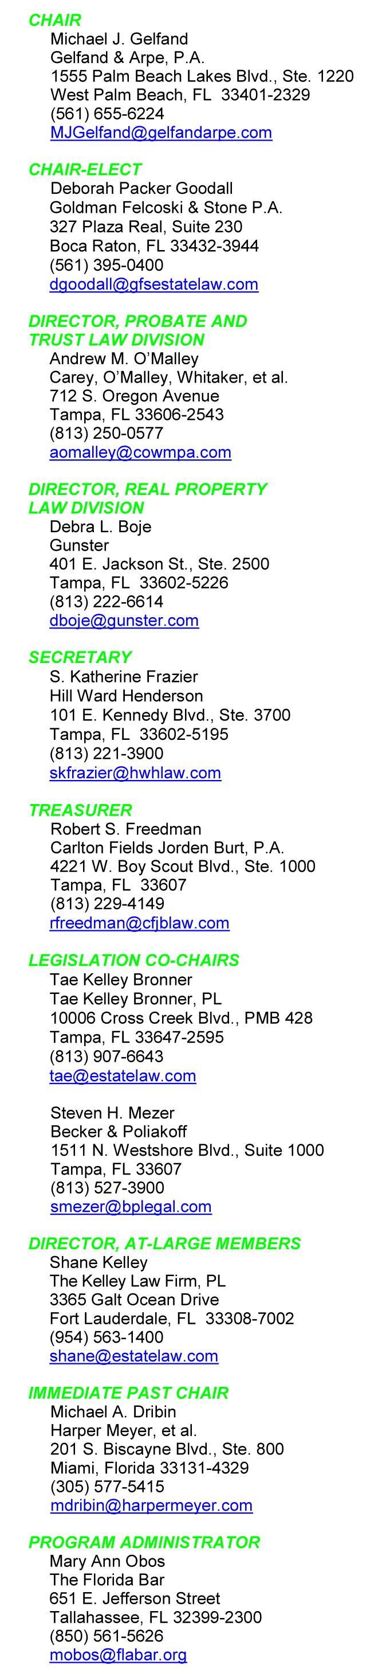
January 28, 2016
Dear Executive Council Members:
Welcome to Tampa! Our “in season” meeting returns to Tampa, easily accessible, reasonable, cultural and historic, is a great place to visit. We will be vetted with the perfect combination of up to date information, comradery, food and wine!
The Tampa Waterside Marriott hosts our Committee and Executive Council Meetings. Centrally located. Easily accessible. Beautiful vistas. The Waterside Marriott beckons.
Tampa’s offerings are multifold. On one side is Cotanchobee Fort Brooke Park. On the other side is the Convention Center. Across the street is the Sports Arena. Just down the street are the Aquarium and the History Center. Outside the rear doors and across the bridge is Harbor Island.
The detailed schedule? Though posted at www.RPPTL.org, go paperless and instantly updated with the RPPTL app. The Tampa materials are scheduled to be up on the app by the start of February, an email will be sent with instructions. Committee agendas are still published the “old fashioned” way at www.RPPTL.org, dependent on humans, that is committee volunteers, updating webpages. [This is just a subtle reminder to committees to update their meeting materials on www.RPPTL.org.]
Attached is our registration form. You are requested to complete and return the form as soon as possible to the Florida Bar. There is no reason to delay, but the registration deadline is February 12, 2016. A separate committee member registration form is distributed separately and to avoid confusion please do not distribute this letter and form to non-Council committee members.
Our daily summary schedule of activities, food for the intellect and body:
Thursday, February 25. Time to arrive. Most committee meetings start at lunch time. Knowing how we work, sign up for the scrumptious lunch.
Thursday Evening, February 25. Close the laptops, cover the tablets, place phones into mute. It is time to welcome each other, spouses, and significant others for heavy hors d’oevures. Afterwards we will retire to the “suite” for drinks and little delectables.
Friday, February 26. Stretch a leg with Mike Bedke and the Reptile Runners at 6:30 a.m. starting from the lobby. Running or not, energize with breakfast. Pat Meyer graciously hosts a spouse and guest breakfast, a wonderful time for them to catch up with each other and to greet newcomers. Power up mid-day by signing up for our buffet lunch. Council members attend their respective Division Roundtables at 3:00 pm.
Friday Evening, February 26. After cocktails and passed treats, we have a sit-down plated dinner. Concluding the evening, all Council members and their spouses/guests are invited to the “suite”, for additional delights.
Saturday, February 27. Start with our traditional hearty hot breakfast. Arrive early, fill up and catch up with your friends you have not seen since Boca Raton. The reason for the gathering, our Executive Council Meeting starts at 9:00 a.m. Mandatory attendance for Council members, please ensure that you review the Agenda well in advance.
Saturday afternoon see Tampa, and for a limited number, exercise a unique opportunity to attend a Broadway road show. The show is Matilda. Legislative Co-Chair Steven Mezer, moonlights as a Trustee of the Straz Center for the Performing Arts, and he volunteered to seek good seats for the 2:00 p.m. matinee performance of Matilda. The Broadway show’s acclaim includes four Tony awards. As a special event, Steve might be able to arrange a meeting with the cast, subject to their availability of course, and the number of registrations for the show.
Otherwise, there is plenty in the neighborhood, plan your own agenda, water, land and sky, or just trust serendipity, at least until dinner.
Saturday Evening February 27. Sangria and Flamenco! The Historic Columbia House welcomes us with an authentic Cuban meal from including the house special Snapper, traditional Ropa Vieja, and the outstanding Paella. Do not fear, there will be plenty of plantanos, rice and beans. Let us see who can dance the Flamenco!
Sunday, February 27. Enjoy Tampa, early and quiet, or check out the Hotel’s brunch.
Meetings, events, food, wine are interesting, fun and exciting! Please return your registration forms as soon as possible, but no later than Friday, February 12, 2016.
Looking forward to seeing you in Tampa.
Very truly yours,

Michael J. Gelfand, Chair

P.S. “A well-educated citizenry is the foundation of our democracy!” Attributed to Thomas Jefferson, this quote could be a RPPTL touchstone, recognizing what we do in the halls of the Legislature to the halls of justice, to the homes of our clients. As Council members, we have the tools to ensure that our children, nieces, nephews, and grandchildren have what it takes to thrive in the education system and thereafter. Conversely, we know what happens to children without those tools.
Take a brief moment, join with the Section’s officers and bring to the meeting donations of school supplies. This is a small, almost insignificant effort for each of us, but with great impact on student recipients. Yes, many if not all of us volunteer in our hometown schools; but, our venue, like every large city, has seen an influx of economically disadvantaged refugee families and many of the local Title 1 schools are in need of school supplies for the elementary school children.
Let us see what we can do for the students in our host city. All donations are appreciated, but a quick list is: new (unused) #2 pencils; colored pencils; blue, black or red pens; washable markers; dry erase markers; wide rule loose leaf notebook paper; rulers, glue sticks, erasers, and back packs.
Local high school students will be on site Saturday morning volunteering to collect school supplies for elementary schools in need. Our ALMs will be volunteering at the check in desk to accept donations Thursday and Friday. Because of the peculiarities of distribution and school requirements, checks cannot be accepted.
So, stick extra packs of pencils, markers and whatever else fits, in your luggage and briefcase to help the local elementary schools. Every bit helps.
Thank you.

F:\WP\RPPTL\160111Chairs Letter Tampa 2016.docx

Recalling “the” question of 2010, “Where were you when the lights went out?” Those returning for a 20 flight stairwell climb will be disappointed! Written into our contract, the Marriott confirms that backup systems are operational, including testing generators a week before arrival!

